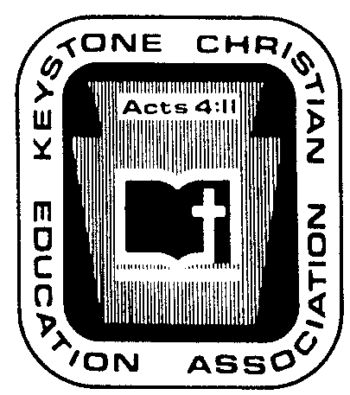
Keystone Christian Education Association

6101 Bell Road

Harrisburg, PA 17111
Phone (717) 564-1164

Fax (717) 564-1163

E-mail TClater@KCEA.com

Web www.KCEA.com

NOVEMBER ’23 NEWS NOTES

P.R. IDEA OF THE MONTH. CHICK-FIL-A’S LEADERSHIP ACADEMY. It should not be forgotten that curriculum in schooling is far more than textbooks. Curriculum encompasses the entire school day. Similarly, the gaining of skills is far more than academic prowess. Skills include a full range of what professionals refer to as soft skills, core skills, key skills.

Curriculum planning and skill planning are important activities, but they often get overlooked.

I just reviewed a brief report of an evangelical Christian school utilizing Chick-Fil-A’s Leadership Academy to aid the faculty in its effort to develop high school students for life. The development of leadership does not just happen. Whatever occurs by accident can be enhanced by institutional planning, by purposely building experiences and content into the regular schedule of a high school.

A local Chick-Fil-A franchise must sponsor a school’s program. To learn more, see https://chickfilaleaderacademy.com/.

IMPORTANT ACTIVITIES TO REMEMBER IN DECEMBER:
…
…
…

2023 ALL STATE CHOIR COMPLETED, PLAN FOR CORRECT DATE FOR 2024. The 2023 Choir saw 130 singers learn and grow under the leadership of Professor Dr. Russ Shelley. Enthusiasm was, and continues to be, high. Many are commenting that singing in the Rotunda was special. The public concert has been archived on the website of the hosting church. Scroll to November 18 at https://www.youtube.com/channel/UCEotjxjCLwQ66Xn1DlQfUdg/live.
…
…
…

ARE YOU USING YOUR LOGICAL ARGUMENT INVOLVING “IDENTIFYING” We previously shared a worthwhile way to battle against the current, in-vogue trans movement.
…
…
…

THE EMPLOYEE RETENTION TAX CREDIT PROGRAM. There is strong reason for affiliating schools to view this Covid era program as philosophically different from the government “give away” programs. Here, a qualified employer claims a refund on taxes it paid to the federal government.
…
…
…

LEGISLATIVE CONTACTS PRAISING EITC NEEDED.
…
…
…

KCEA BUSINESS AT A GLANCE. Here is a summary of the discussions at the most recent KCEA Board meeting held on Monday, November 13, 2023, at the KCEA office at Harrisburg. The meeting covered about five hours, including lunch.
…
…
…

TRANSPARENCY REGARDING OTHER SCHOOL ASSOCIATIONS. The year 2023 saw another round of discussions by the KCEA Board as its members work to lead and provide oversight of KCEA regarding other organizations. While a thorough presentation would be too lengthy for the readership, we provide a quick summary.

…

KCEA has carefully sought to be unchanging in its doctrinal statement and mission. It has a focus of “protecting and promoting Christian education.” It is local, enabling personal relationships and helps. It has a doctrinal statement that includes the standard attributes of orthodox Christianity combined with a clear messaging that its views of Scripture are incompatible with the ecumenical movements of modern times. Today, “everyone” is a “Christian” and will sign any doctrinal statement. An ecumenical spirit is common practice in many Christian schools and groups.

KCEA has a loyal constituency that accesses a variety of programs and services. Yet within KCEA there is variety. Schools vary (a) in their preference for textbooks and Christian colleges and in their working definition of “quality education,” (b) in size and methodology and local church-embraced doctrines, (c) in linkage by church schools with different church fellowships and associations, (d) in preferences for songs and hymn books, including doctrinal traits, (e) and more. KCEA does not seek to impede local autonomy in these matters but to strengthen it. Similarly, KCEA does not impede local autonomy if a school seeks to be part of a national school group if it does not violate our doctrinal statement, and through the decades some have chosen to do so.

Summary? KCEA is distinctive. KCEA serves and is praised for its work. KCEA respects the autonomy of each affiliating ministry. Oh, and KCEA welcomes like-minded brethren.

SPEAKERS AND WORKSHOP PERSENTERS FOR SEPTEMBER 2024. HELP!!!
…
…
…

FACULTY SCHOLARSHIP PROGRAM EXPANDED. For the past three years, KCEA has been assisting faculty within affiliating schools to undertake graduate courses to enhance their ministry. A scholarship has paid a significant part of the cost.
…
…
…

TEC:sc

